Memo
To : To whom it may concern
CC : Rumwell Reginald(SHS US XDCR CD-TRE); Kang, SungYoul(SHS US XDCR CD-TRE TDS MPE); Kim, GiSeok(SHS US XDCR CD-TRE TDS MPE)
From : Park, SoYun (SHS US XDCR CD-TRE TDS MPE)
Date : Dec 23rd ,2020
This memo describes that transducers which have compatibility with CIDEX OPA can be used for DISOPA.

- Executive Summary:
This memo is to justify that transducers which have compatibility with Cidex OPA can be used for DISOPA. This memo will be a justification to update compatible disinfectants in the Transducer Disinfectant Compatibility Matrix (P/N 11335653).

- Disinfectants:
Disinfectants | Cas No | Active Ingredient | Concentration
DISOPA | 643-79-8 | Ortho-phthalaldehyde | 0.55%
CIDEX OPA | 643-79-8 | Ortho-phthalaldehyde | 0.55%

- Analysis:
DISOPA could be used for transducers which CIDEX OPA has been compatible with. That’s because it has a same active ingredient as CIDEX OPA. In addition, the manufacturer of CIDEX OPA has mentioned that DISOPA is re-branded for the Japan market. For those reasons, it is considered that both products have the same properties and it will cause same results of material compatibility.

- Compatible Transducers:
DISOPA could be used for transducers which CIDEX OPA is compatible with and they are marked in red letters.
(C = Compatible / F = Not Compatible, tested / Blank = Not tested)

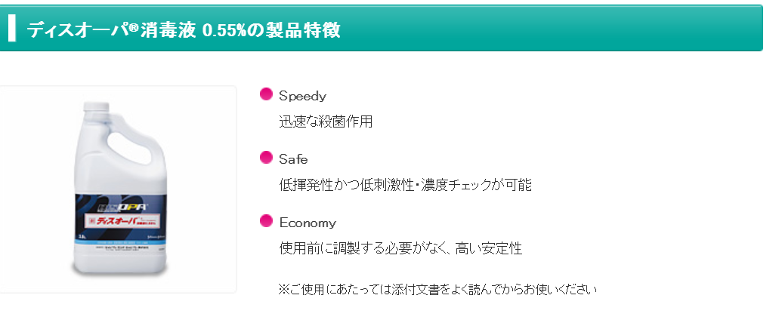
Picture 1 Technical Information of DISOPA

- conclusion:
Transducers which are compatible with CIDEX OPA can be used for DISOPA. This justification will be updated on Disinfectant Compatibility Matrix (P/N 11335653).

- References:
Document Description | P/N
[1] Transducer Disinfectant Compatibility Matrix | P/N 11335653
[2] Transducer Family Classification for Reprocessing | P/N 11508925
[3] Cleaner and Disinfectant Family Classification | P/N 11508294

- Appendix:
- SDS of DISOPA
